**About Us**

PMBPPCL aka Pisangan Mahila Bakri Palak Producer Company Limited is transforming lives of lady marginal farmers and women are being empowered to break the cycle of extreme poverty and debt slavery. By providing online visibility, we are trying to ensure that the information of great quality goat with historic data and traceability, can be at buyer’s fingertips and an excellent quality of meat is available to end costumer.

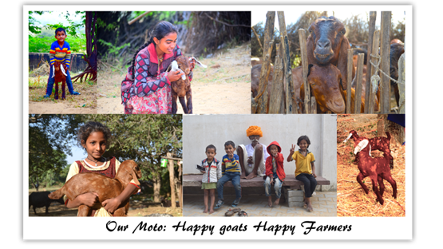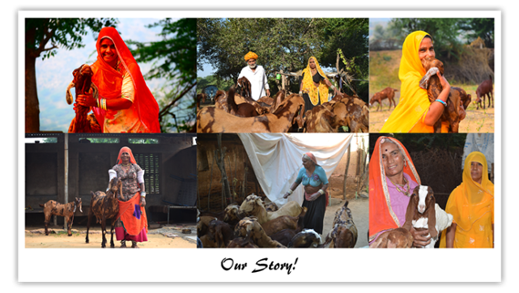 **Our Motto: Happy Goats Happy Farmers**

**Our Story**

In a picturesque hamlet of Pisangan, Ajmer, Rajasthan, Sarita Devi is content after a day’s work. Her goats bleat outside, are life savior and bread winner for her.

She was faced with mammoth task of raising her children after demise of her husband. The prospects were bleak. She then took training of goat farming and was donated few goats by RACP, given means (like weighting scale, feeder, medicines, teat dip, etc ) to raise the goats in stress free and natural pasture fed way. Today she has good earning and a source for inspiration to all.

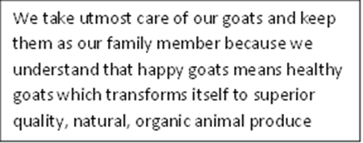

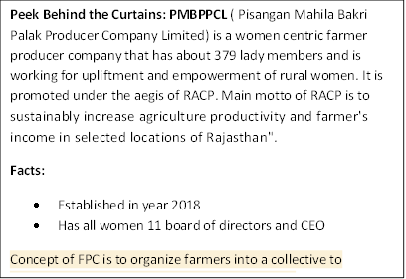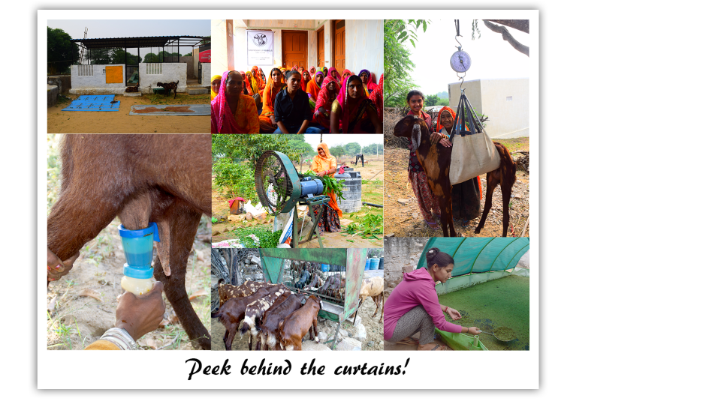

**Backward Integration: Our Strength**

Slider of traceability

Small ruminant rearing ensures self-employment and acts as a cushion in distress situations like drought and famine. Worldwide consumers are preferring products that are “clean, green and ethical”. As such goat producers are shifting to husbandry practices that do not compromise the welfare of animals.

Throughout the history of business, people use **data** to make more informed decisions. But data, traceability and technology, these buzz words were missing from goat industry. Then we came in picture. We do animal’s ear tagging and the information is scanned on the app with health, breeding and other management details of animals. Backward integration of animals gives us a unique precision livestock farming, forecasting and preventive health care management capacity.

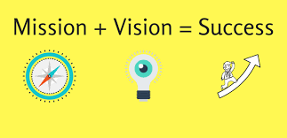

**Mission:** To provide women economic freedom, overall upliftment and social security.

**Vision:** To make Pisangan a model FPC of International fame and its model should be replicated all over India

Location : Map of Pisangan from google maps

